CTODS Lab Viewer

caXChange – ScenPro, Inc.
Ekagra
Design Document

DOCUMENT CHANGE HISTORY
Version Number | Date | Contributor | Description
1.0 | 11/27/07 | Michael Holck | Initial Draft that describes the design of the elements included in the Elaboration phase
1.1 | 1/7/08 | Michael Holck | Added information describing the elaboration phase and construction phase I components
1.2 | 1/8/08 | Kalpesh S. Patel | Added caXchange Hub design information.
1.3 | 1/10/08 | Kalpesh S. Patel | Added Logging and Auditing design information.
1.4 | 1/17/08 | David Dorman | Update information presentation and separated out the Hub design to its own document
1.5 | 1/17/08 | Michael Holck | Updated with latest design
1.6 | 2/14/08 | Michael Holck | Reviewed and Updated with the latest information


Updated February 14, 2008

TABLE OF CONTENTS
1.0 Background/Summary 1
2.0 Introduction 2
2.1 Overview 2
2.2 Scope 2
2.2.1 Clinical Trial Object Data System (CTODS) Grid Services 2
2.2.2 CTODS Lab Viewer 2
2.3 Related Documentation 3
3.0 Design 4
3.1 CTODS Grid Services 4
3.1.1 CTODS Grid Services Class Diagram 4
3.1.2 CTODS CT Lab Load Grid Service Sequence Diagram 6
3.1.3 CTODS Register Subject Grid Service Sequence Diagram 6
3.1.4 CTODS Create Study Grid Service Sequence Diagram 8
3.2 CTODS LAB VIEWER 8
3.2.1 Lab Viewer Login 9
3.2.1.1 Lab Viewer Login Class Diagram 9
3.2.1.2 Lab Viewer Login Sequence Diagram 10
3.2.2 Lab Viewer Query 10
3.2.2.1 Lab Viewer Query Class Diagram 10
3.2.2.2 Lab Viewer Query Sequence Diagram 12
4.0 Glossary 13
LIST OF FIGURES
Figure 1 CTODS Grid Services Class Diagram 5
Figure 2 CTODS CT Lab Load Data Sequence Diagram 6
Figure 3 CTODS Register Subject Sequence Diagram 7
Figure 4 CTODS Create Study Sequence Diagram 8
Figure 5 Lab Viewer Login Class Diagram 9
Figure 6 Lab Viewer Login Sequence Diagram 10
Figure 7 Lab Viewer Query Class Diagram 11
Figure 8 Lab Viewer Query Sequence Diagram 12
LIST OF TABLES
Table 1 caXchange Hub Related Documents 3

Background/Summary
The CTODS Lab Viewer is an application that allows users to view and query lab data persisted in the CTODS Lab Domain database. This application also integrates with the other applications in the CCTS suite by sending and receiving messages from them via the caXchange Hub. In addition to the Lab Viewer there is the Cancer Center Hub Client (CCHC) application that is used to transform clinical lab data from CSV or HL7v2 format to HL7v3 and submit it to the hub for persistence in Lab Viewer. While the CCHC is not strictly a component of the Lab Viewer application itself it is the easiest way for the end user to get lab data into CTODS for display in Lab Viewer so it’s design is presented here as well.

Introduction

Overview
This Design document captures the software design for only the software components of the CTODS Lab Viewer and Cancer Center Hub Client version 1.0. The Cancer Center Hub Client is used to submit laboratory data to CTODS and the CTODS Lab Viewer application is used to view this lab data. The Lab Viewer will also be interoperable with other CCTS applications by receiving and sending messages via the hub.

Scope
The scope of this document is limited to only the design of the caXchange components detailed in the following sections.

Clinical Trial Object Data System (CTODS) Grid Services
The CTODS Grid Services is a collection of grid services used to persist data into the CTODS Lab Domain database. The CTODS Grid Services persist the HL7v3 Laboratory Observation Periodic Report message, as well as the C3PR v2.0 Patient Registration message and C3PR v2.0 Study creation message.

CTODS Lab Viewer
The CTODS Lab Viewer is a web based application developed by leveraging the SDK generated APIs of the CTODS Lab Domain UML model. In the original caXchange v0.5 effort, laboratory data from a cancer center was being transformed, routed, and persisted into the CTODS Lab Domain database, but there was no visual and user friendly GUI tool to view the laboratory data that got stored in CTODS database. Based on the use cases identified by the SMEs of the CTMS Interoperability project, a new requirement was identified that made the viewing of lab data from CTODS a critical piece of the CTMS interoperability project.
The CTODS Lab Viewer allows users to view laboratory activities records that are stored in the CTODS Lab Domain database. Users will be allowed to search the laboratory activity records by Patient Id, Study Id, Lab Start Date, and Lab End Date. When the search results are displayed, numeric results that are outside the high and low reference ranges of the lab tests will be highlighted to alert the user. This visual alert/trigger will allow the user to focus in and act on those specific lab test results.
Additionally, the CTODS Lab viewer will allow users to send lab data to the local CDMS application (C3D). The functionality to select which labs should be loaded into the CDMS will be provided in the CTODS Lab Viewer interface.

Related Documentation
For additional information on caXchange Hub, version 1.0, please refer to following documents:
Table 1 caXchange Hub Related Documents
Document | Version | Location
caXchange Use Case Specification and Realization Document | 1.0 | https://gforge.nci.nih.gov/plugins/scmcvs/cvsweb.php/caxchange/Deliverables/Use%20Case%20Specification%20and%20Realization%20Documents%20(Task%202.1).rtf?cvsroot=caxchange
caXchange Software Requirements Specification Document | 1.0 | https://gforge.nci.nih.gov/plugins/scmcvs/cvsweb.php/caxchange/Deliverables/Software%20Requirement%20Specifications%20(Task%202.2).doc?cvsroot=caxchange
caCORE 3.2_Tech_Guide (Chapter 10: Common Logging Module)
CSM – User Provisioning Tool User Guide |  | (ftp://ftp1.nci.nih.gov/pub/cacore/CSM/UPT_User_Guide.pdf)
Servicemix Documentation |  | http://servicemix.apache.org/documentation.html
Java Business Integration Specification |  | http://jcp.org/en/jsr/detail?id=208
caXchange Interface Specification |  | https://gforge.nci.nih.gov/plugins/scmcvs/cvsweb.php/caxchange/Documentation/Interface/caXchange_Interface_Specification.doc?cvsroot=caxchange
caXchange Design Diagram |  | https://gforge.nci.nih.gov/plugins/scmcvs/cvsweb.php/caxchange/Documentation/Design/reliable-messaging-diagram.odg?cvsroot=caxchange

Design

The design of the caXchange components are detailed in the following sections.

CTODS Grid Services
The CTODS Grid Services will be developed using the caBIG Introduce tool to generate the stubs and skeleton implementation. The following diagrams only reflect the classes that were implemented by the caXchange team for these services and do not include classes that were automatically generated by the Introduce toolkit.

CTODS Grid Services Class Diagram
The classes that implement the CTODS Grid Services are shown below.
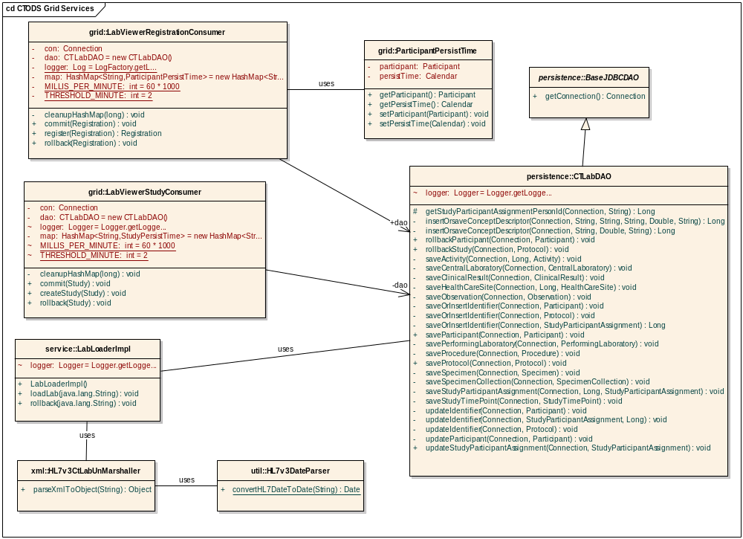
Figure 1 CTODS Grid Services Class Diagram

CTODS CT Lab Load Grid Service Sequence Diagram
The sequence diagram in the Figure below shows the sequence of events that occur when the caXchange hub calls the CTODS CT Lab Load Grid Service. The string that is passed in to the loadLab method must be an HL7v3 CT Lab Message.
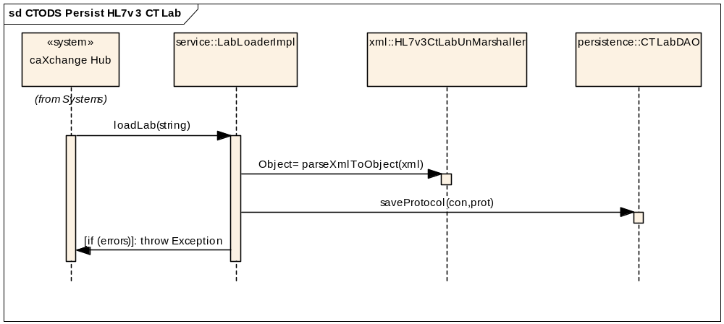
Figure 2 CTODS CT Lab Load Data Sequence Diagram

CTODS Register Subject Grid Service Sequence Diagram
The sequence diagram in the Figure below shows the sequence of events that occur when the caXchange hub calls the CTODS Register Subject Grid Service.
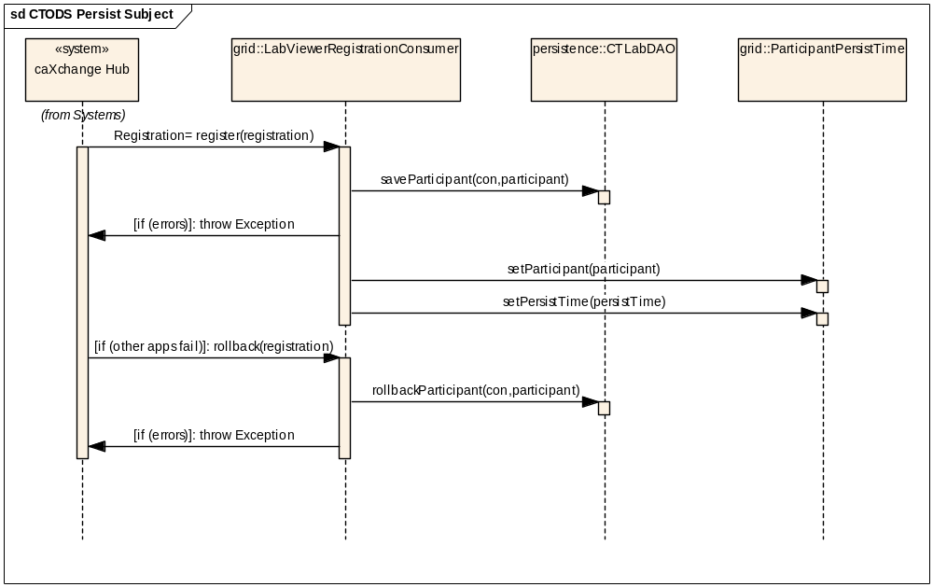
Figure 3 CTODS Register Subject Sequence Diagram

CTODS Create Study Grid Service Sequence Diagram
The sequence diagram in the Figure below shows the sequence of events that occur when the caXchange hub calls the CTODS Create Study Grid Service.
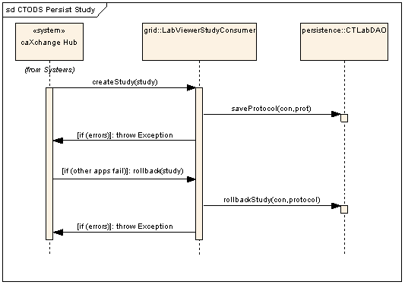
Figure 4 CTODS Create Study Sequence Diagram

CTODS LAB VIEWER
The CTODS Lab Viewer is a J2EE web application that uses the Struts framework. The actual implementation consists of several classes that include the actions, forms, and view objects and a single class diagram would be difficult to read. As such we will present the design in sections that implement the use cases of the system and only show the relevant classes for these.

Lab Viewer Login
The first use case that will be presented is the Login use case. This simply requires the user to login to the application and be authorized to use it. Lab Viewer uses the NCICB Common Security Module (CSM) for implementing authentication and authorization.

Lab Viewer Login Class Diagram
The classes that implement the Login use case are show below.

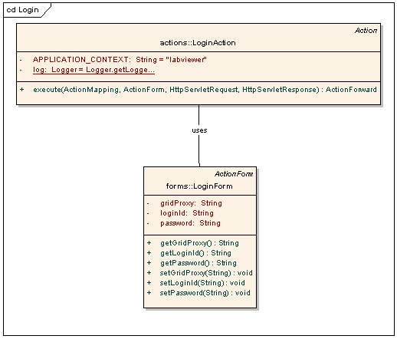
Figure 5 Lab Viewer Login Class Diagram

Lab Viewer Login Sequence Diagram
The sequence diagram in Figure 6 shows the sequence of events that occur when the user logs into the application.
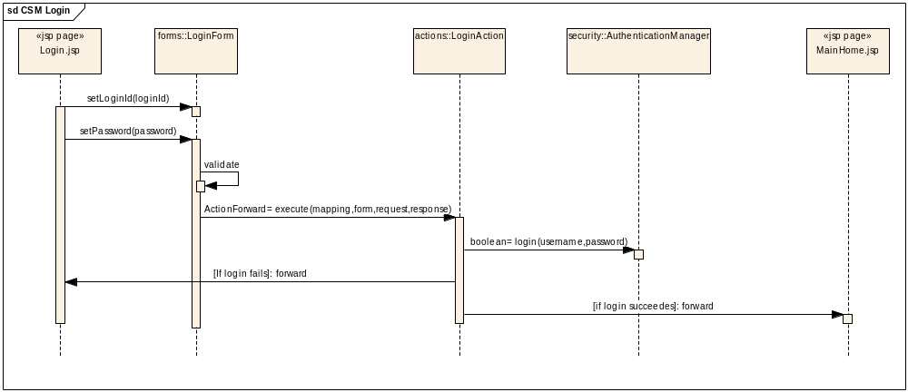
Figure 6 Lab Viewer Login Sequence Diagram

Lab Viewer Query
The Lab Viewer Query use case involves a user searching the CTODS database for lab results and viewing the results.

Lab Viewer Query Class Diagram
The classes that implement the query use case are shown below.
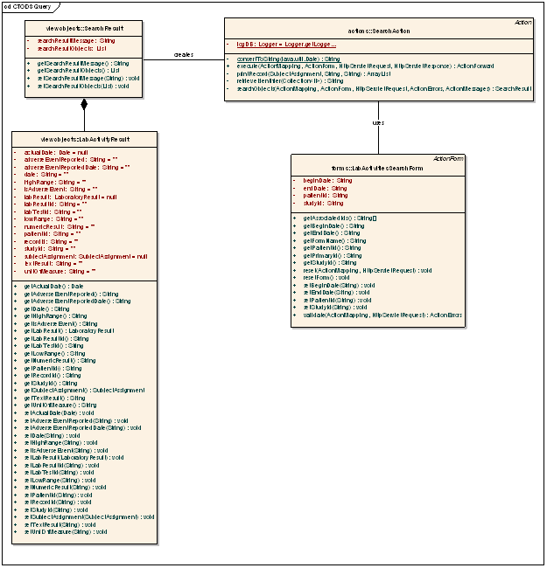
Figure 7 Lab Viewer Query Class Diagram

Lab Viewer Query Sequence Diagram
The sequence diagram in Figure 8 shows the sequence of events that occur when the user queries for lab data.
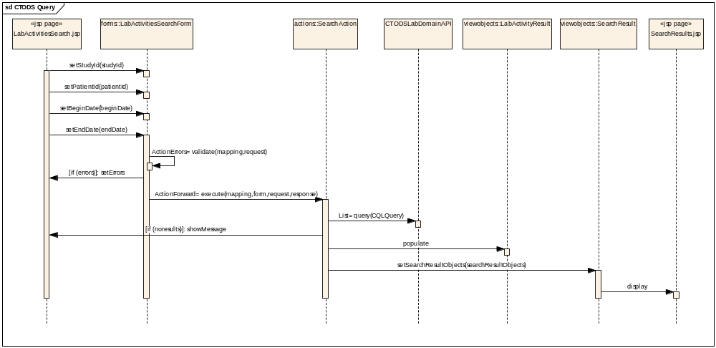
Figure 8 Lab Viewer Query Sequence Diagram

Glossary

Term | Definition
NCICB | National Cancer Institute Center for Bioinformatics
BPEL | Business Process Execution Language
C3PR | Cancer Central Clinical Participant Registry
caAERS | Cancer Adverse Event Reporting System
GUID | A unique ID that the Enterprise Architect product assigns to each object that is created by the tool.
CCHC | Cancer Center Hub Client. The software that is responsible for sending patient laboratory data to the Lab Hub via an interface exposed by the HUB
Endpoint | A destination to which the hub can route data to. An endpoint can represent a service deployed on the hub or an external system to which the hub routes data.
CTMSI | Clinical Trials Management System Interoperability
CCTS | Cancer Clinical Trials Suite
CTODS | Clinical Trials Object Data System

